**Machine Learning**

**COCSC17**

**PRACTICAL FILE**



**Submitted by:-**  **Submitted to:-**

2020UCO1580 Prof. Shubhra Goyal

Anurag Verma

**INDEX**

|  |  |  |
| --- | --- | --- |
| **Serial No.** | **Title** | **Teacher’s Signature** |
| 1 | Implement Linear Regression algorithm for Head Brain dataset. |  |
| 2 | Implement Logistic Regression Algorithm on Diabetes Dataset |  |
| 3 | Implement Naïve Bayes Algorithm for Diabetes Dataset |  |
| 4 | Implement K-Nearest Neighbor Algorithm on Diabetes Dataset |  |
| 5 | Implement K-Means Clustering Algorithm on Mall Customers Dataset |  |
| 6 | Implement Decision Tree using Plant Iris Dataset |  |
| 7 | Implement CNN |  |

**PRACTICAL-1**

**AIM:**

Implement Linear Regression algorithm for Head Brain dataset.

**Code & Outputs:**

import pandas as pd

import numpy as np

from matplotlib import pyplot as plt

df = pd.read_csv('headbrain.csv')

df.shape



df.info()

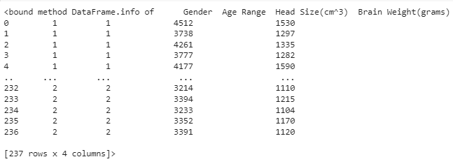

plt.scatter(df['Head Size(cm^3)'], df['Brain Weight(grams)'])

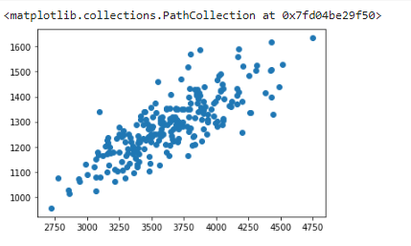

from sklearn import linear_model

reg = linear_model.LinearRegression()

reg.fit(df[['Head Size(cm^3)']], df['Brain Weight(grams)'])



reg.predict([[3000]])



plt.plot(df['Head Size(cm^3)'], reg.predict(df[['Head Size(cm^3)']]), marker = '+')

plt.scatter(df['Head Size(cm^3)'],  df['Brain Weight(grams)'], color = 'red')

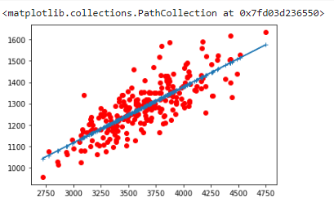

**PRACTICAL-2**

**AIM:**

Implement Logistic Regression Algorithm on Diabetes Dataset

**Code & Output:**

import numpy as np

import pandas as pd

import seaborn as sns

from matplotlib import pyplot as plt

%matplotlib inline

df = pd.read_csv("diabetes.csv")

df.head()

# It will show top 5 rows

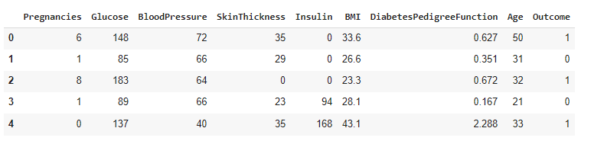

df.describe()

# It will show DataFrame

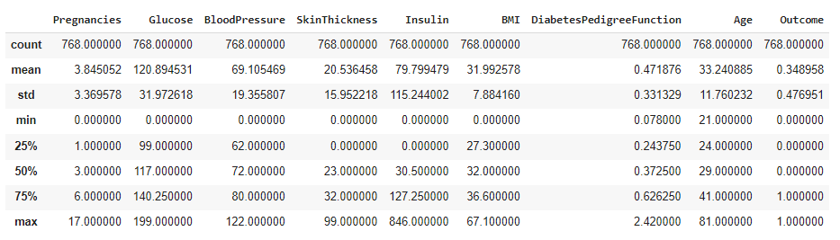

sns.heatmap(df.isnull(), yticklabels=False, cmap = 'viridis')

#It will plot heatmap graph with respect to no of null values

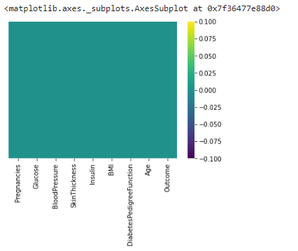

sns.heatmap(df, yticklabels = False, cmap = 'viridis')

#It will give heatmap graph with respect to values in the column

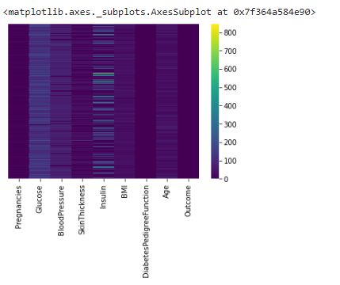

sns.set_style('whitegrid')

sns.countplot(x='Outcome', hue = 'Outcome', data = df, palette = 'cubehelix')

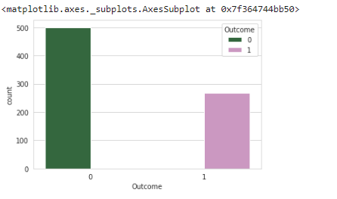

plt.scatter(x = 'Outcome', y = 'Age', data = df)

plt.ylabel('Age')

plt.xlabel('Outcome')

#It gives scattered(dotted) graph between Outcome and Age

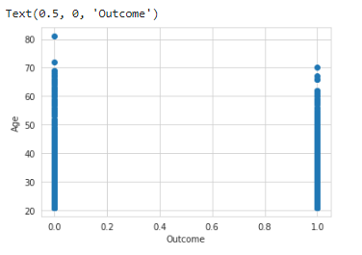

sns.displot(df['Age'], kde = False, color = 'red', bins = 30)

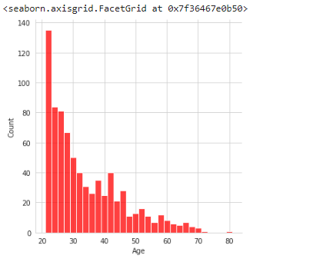

sns.displot(df['BloodPressure'], kde = False, color = 'purple', bins = 20)

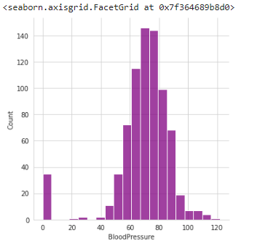

sns.jointplot(x = 'Age', y = 'BloodPressure', data = df, color = 'green')

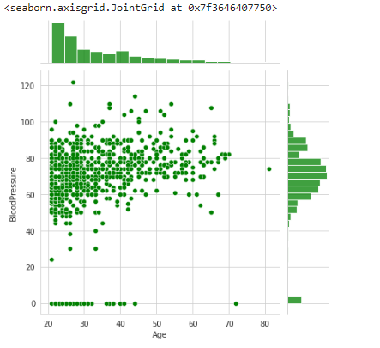

sns.set(style = "whitegrid")

plt.figure(figsize = (15, 8))

ax = sns.barplot(x = 'Age', y = 'BloodPressure', data = df)

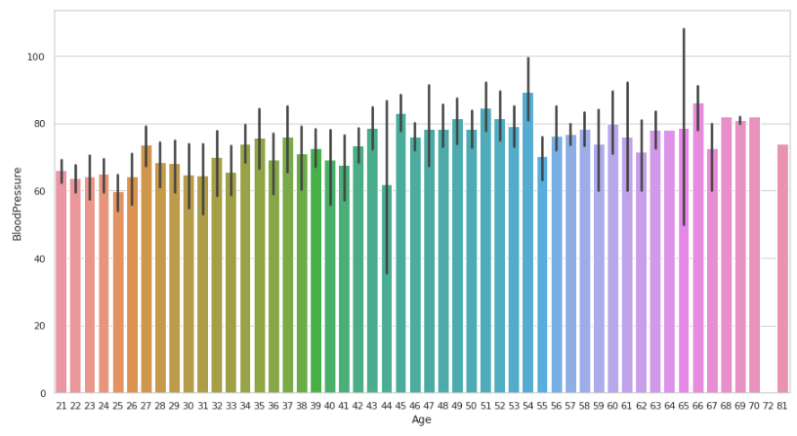

from sklearn.model_selection import train_test_split

x = ['Pregnancies', 'Glucose', 'BloodPressure', 'SkinThickness', 'Insulin', 'BMI', 'DiabetesPedigreeFunction', 'Age', 'Outcome']

y = ['Output']

from sklearn.model_selection import train_test_split

X_train, X_test, y_train, y_test = train_test_split(df.drop('Outcome', axis = 1), df['Outcome'], test_size=0.20,random_state=101)

from sklearn.linear_model import LogisticRegression

LRModel = LogisticRegression(solver = 'lbfgs', max_iter = 7500)

#max_iter defines the maximum iterations while using LogisticRegression

LRModel.fit(X_train, y_train)



predictions_diabetes = LRModel.predict(X_test)

from sklearn.metrics import classification_report as cr, confusion_matrix as cm

print(cr(y_test, predictions_diabetes))

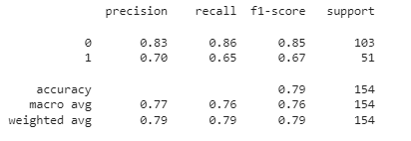

x=['Pregnancies','Glucose','BloodPressure','SkinThickness','Insulin','BMI','DiabetesPedigreeFunction','Age']

data = [0, 170, 126, 60, 35, 30.1, 0.649, 78]

pt = pd.DataFrame([data], columns = x)

pt.head()



predictions_diabetes = LRModel.predict(pt)

print(predictions_diabetes)



**PRACTICAL-3**

**AIM:**

Implement Naïve Bayes Algorithm for Diabetes Dataset

**Code & Output:**

import pandas as pd

import numpy as np

import seaborn as sns

from sklearn.metrics import confusion_matrix, f1_score, accuracy_score, classification_report

from sklearn.naive_bayes import GaussianNB

from sklearn.model_selection import train_test_split

df = pd.read_csv("diabetes.csv")

df.head()

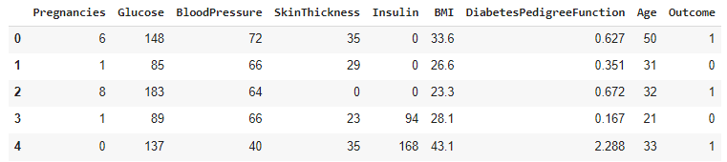

df.describe()

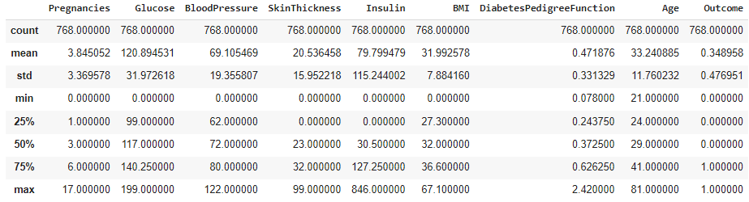

x = ['Pregnancies', 'Glucose', 'BloodPressure', 'SkinThickness', 'Insulin', 'BMI', 'DiabetesPedigreeFunction', 'Age', 'Outcome']

y = ['Output']

X_train, X_test, y_train, y_test = train_test_split(df.drop('Outcome', axis = 1), df['Outcome'], test_size=0.20,random_state=101)

classifier_Naive = GaussianNB()

classifier_Naive.fit(X_train, y_train)



y_pred = classifier_Naive.predict(X_test)

print(y_pred)

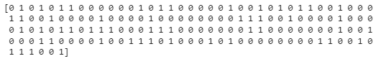

x=['Pregnancies','Glucose','BloodPressure','SkinThickness','Insulin','BMI','DiabetesPedigreeFunction','Age']

data = [0, 170, 126, 60, 35, 30.1, 0.649, 78]

pt = pd.DataFrame([data], columns = x)

pt.head()



#Pridicting on testing data

print(classifier_Naive.predict(pt))



ac = accuracy_score(y_test,y_pred)

cm = confusion_matrix(y_test, y_pred)

print(ac)

print(cm)



**PRACTICAL-4**

**AIM:**

Implement K-Nearest Neighbor Algorithm on Diabetes Dataset

**Code & Output:**

import pandas as pd

import numpy as np

from sklearn.model_selection import train_test_split #Used to train and test the data

from sklearn.preprocessing import StandardScaler #From uniform data

from sklearn.neighbors import KNeighborsClassifier # for KNN

from sklearn.metrics import confusion_matrix, f1_score, accuracy_score # For testing the data

df = pd.read_csv('diabetes.csv')

df.head()

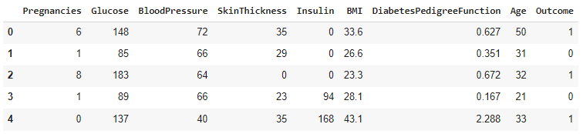

zero_not_accepted = ['Glucose', 'BloodPressure', 'SkinThickness', 'BMI', 'Insulin']

#We will replace zero values present in any of above column values

for column in zero_not_accepted:

  df[column] = df[column].replace(0, np.NaN)

  mean = int(df[column].mean(skipna = True))

  df[column] = df[column].replace(np.NaN, mean)

#Now we will split dataset into training data and testing data

X = df.iloc[:, 0:8]

#It means from all of the columns select 0->7 column as X-axis

y = df.iloc[:, 8]

#Select 8th column from all column as y-axis

X_train, X_test, y_train, y_test = train_test_split(X, y, random_state=0, test_size = 0.2)

#It means 20% of the dataset will be used for testing purpose and rest for training purpose

#Scaling the data

sc_X = StandardScaler()

X_train = sc_X.fit_transform(X_train)

X_test = sc_X.transform(X_test)

classifier = KNeighborsClassifier(n_neighbors = 11, p = 2, metric = 'euclidean')

#We have deckared KNN with k = 11 using euclidean distance

#p=2 is used because we're looking for the patient is diabetic or not

classifier.fit(X_train, y_train)



#Predicting the test results

y_pred = classifier.predict(X_test)

y_pred

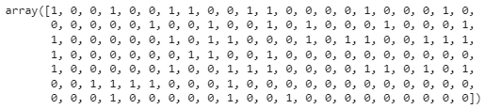

#Evaluating model

cm = confusion_matrix(y_test, y_pred)

print(cm)

print(f1_score(y_test, y_pred))



print(f1_score(y_test, y_pred))



print(accuracy_score(y_test, y_pred))



**PRACTICAL-5**

**AIM:**

Implement K-Means Clustering Algorithm on Mall Customers Dataset

**Code & Output:**

import numpy as np

import matplotlib.pyplot as plt

import pandas as pd

dataset = pd.read_csv('Mall_Customers.csv')

X = dataset.iloc[:, [3, 4]].values

from sklearn.cluster import KMeans

wcss = []

for i in range(1, 11):

    kmeans = KMeans(n_clusters = i, init = 'k-means++', random_state = 42)

    kmeans.fit(X)

    wcss.append(kmeans.inertia_)

plt.plot(range(1, 11), wcss)

plt.title('The Elbow Method')

plt.xlabel('Number of clusters')

plt.ylabel('WCSS')

plt.show()

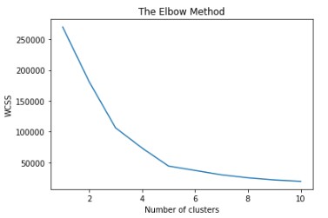

kmeans = KMeans(n_clusters = 5, init = 'k-means++', random_state = 42)

y_kmeans = kmeans.fit_predict(X)

plt.scatter(X[y_kmeans == 0, 0], X[y_kmeans == 0, 1], s = 100, c = 'red', label = 'Cluster 1')

plt.scatter(X[y_kmeans == 1, 0], X[y_kmeans == 1, 1], s = 100, c = 'blue', label = 'Cluster 2')

plt.scatter(X[y_kmeans == 2, 0], X[y_kmeans == 2, 1], s = 100, c = 'green', label = 'Cluster 3')

plt.scatter(X[y_kmeans == 3, 0], X[y_kmeans == 3, 1], s = 100, c = 'cyan', label = 'Cluster 4')

plt.scatter(X[y_kmeans == 4, 0], X[y_kmeans == 4, 1], s = 100, c = 'magenta', label = 'Cluster 5')

plt.scatter(kmeans.cluster_centers_[:, 0], kmeans.cluster_centers_[:, 1], s = 300, c = 'yellow', label = 'Centroids')

plt.title('Clusters of customers')

plt.xlabel('Annual Income (k$)')

plt.ylabel('Spending Score (1-100)')

plt.legend()

plt.show()

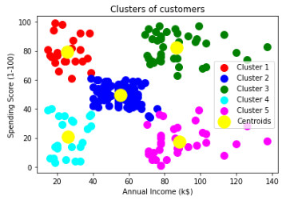

**PRACTICAL-6**

**AIM:**

Implement Decision Tree using Plant Iris Dataset

**Code & Ouput:**

import pandas as pd

import numpy as np

from sklearn.tree import DecisionTreeClassifier

from sklearn import tree

df = pd.read_csv('IRIS.csv')

df.head()

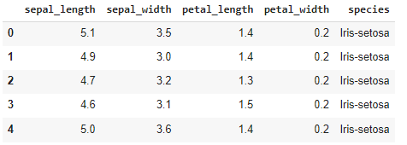

FEATURE_NAMES = ['sepal_length','sepal_width', 'petal_length', 'petal_width']

X = df[FEATURE_NAMES]

y = df['species']

clf = DecisionTreeClassifier(max_depth = 5)

clf.fit(X, y)



TV = ['Iris-setosa', 'Iris-versicolor', 'Iris-verginica']

tree.plot_tree(clf, feature_names = FEATURE_NAMES, class_names = TV);

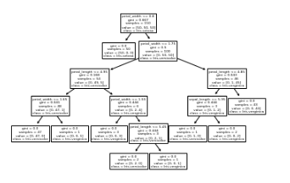

**PRACTICAL-7**

**AIM:**

Implement CNN

**Code & Ouput:**

import tensorflow as tf

from tensorflow.keras import datasets, layers, models

import matplotlib.pyplot as plt

(train_images, train_labels), (test_images, test_labels) = datasets.cifar10.load_data()

# Normalize pixel values to be between 0 and 1

train_images, test_images = train_images / 255.0, test_images / 255.0

class_names = ['airplane', 'automobile', 'bird', 'cat', 'deer',

'dog', 'frog', 'horse', 'ship', 'truck']

plt.figure(figsize=(10,10))

for i in range(25):

plt.subplot(5,5,i+1)

plt.xticks([])

plt.yticks([])

plt.grid(False)

plt.imshow(train_images[i])

# The CIFAR labels happen to be arrays,

# which is why you need the extra index

plt.xlabel(class_names[train_labels[i][0]])

plt.show()

model = models.Sequential()

model.add(layers.Conv2D(32, (3, 3), activation='relu', input_shape=(32, 32, 3)))

model.add(layers.MaxPooling2D((2, 2)))

model.add(layers.Conv2D(64, (3, 3), activation='relu'))

model.add(layers.MaxPooling2D((2, 2)))

model.add(layers.Conv2D(64, (3, 3), activation='relu'))

model.summary()

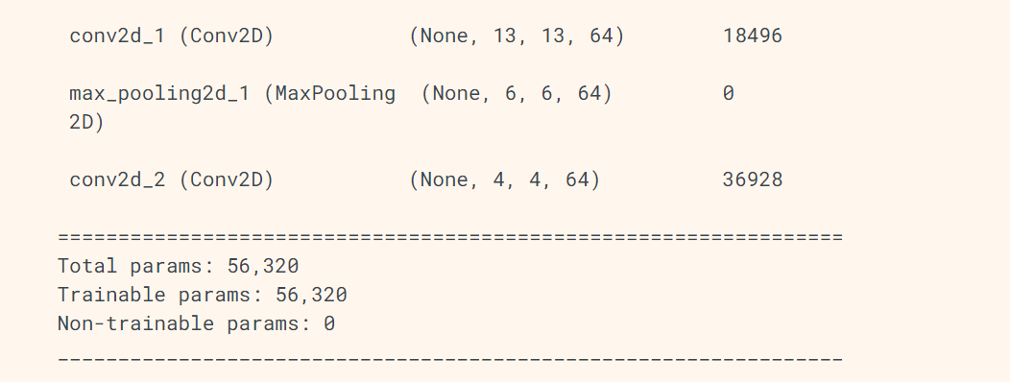

model.add(layers.Flatten())

model.add(layers.Dense(64, activation='relu'))

model.add(layers.Dense(10))

model.summary()

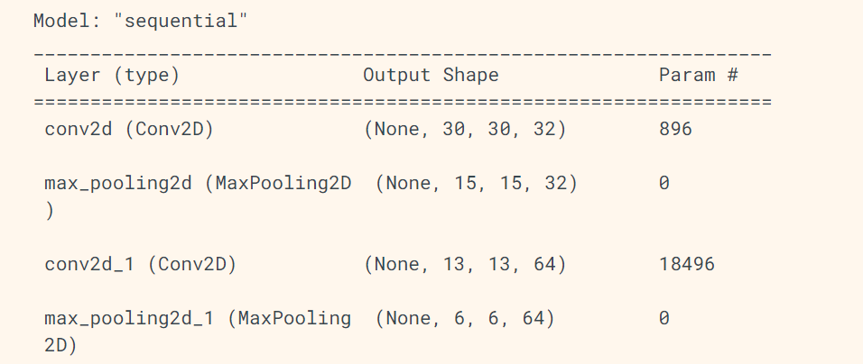

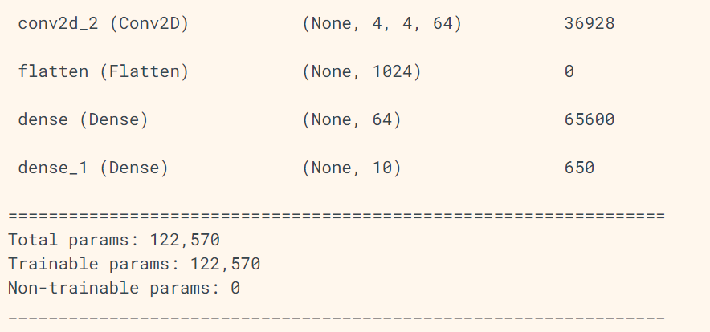

model.compile(optimizer='adam',

loss=tf.keras.losses.SparseCategoricalCrossentropy(from_logits=True),

metrics=['accuracy'])

history = model.fit(train_images, train_labels, epochs=10,

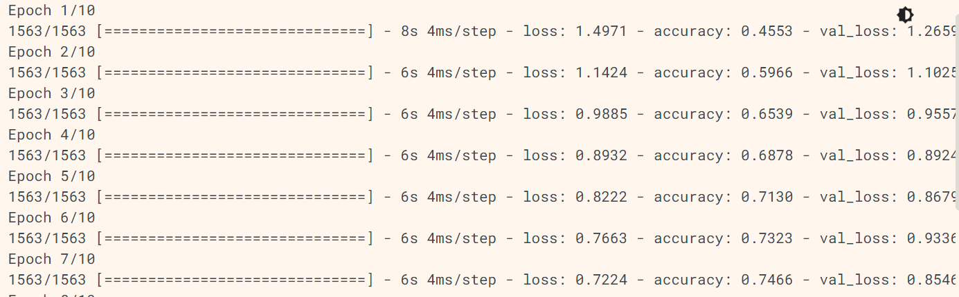

validation_data=(test_images, test_labels))

plt.plot(history.history['accuracy'], label='accuracy')

plt.plot(history.history['val_accuracy'], label = 'val_accuracy')

plt.xlabel('Epoch')

plt.ylabel('Accuracy')

plt.ylim([0.5, 1])

plt.legend(loc='lower right')

test_loss, test_acc = model.evaluate(test_images, test_labels, verbose=2)

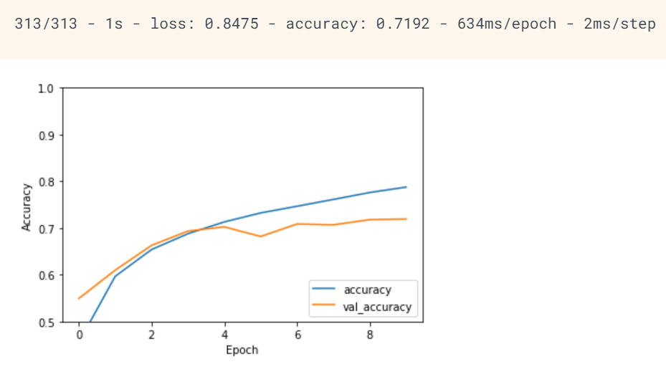

print(test_acc)

